**NAME:** Divyang Bagla

**PANEL:** CC1

**ROLL NO.:** PA35

**PRN:** 1032180739

**SUBJECT:** Cloud Computing

**Assignment No. 2**

**Aim:** Write a web service using java or python. Deploy the service using PaaS tools such as cloud Cloud Foundry/GoogleAppEngine/OpenShift/Microsoft Azure.

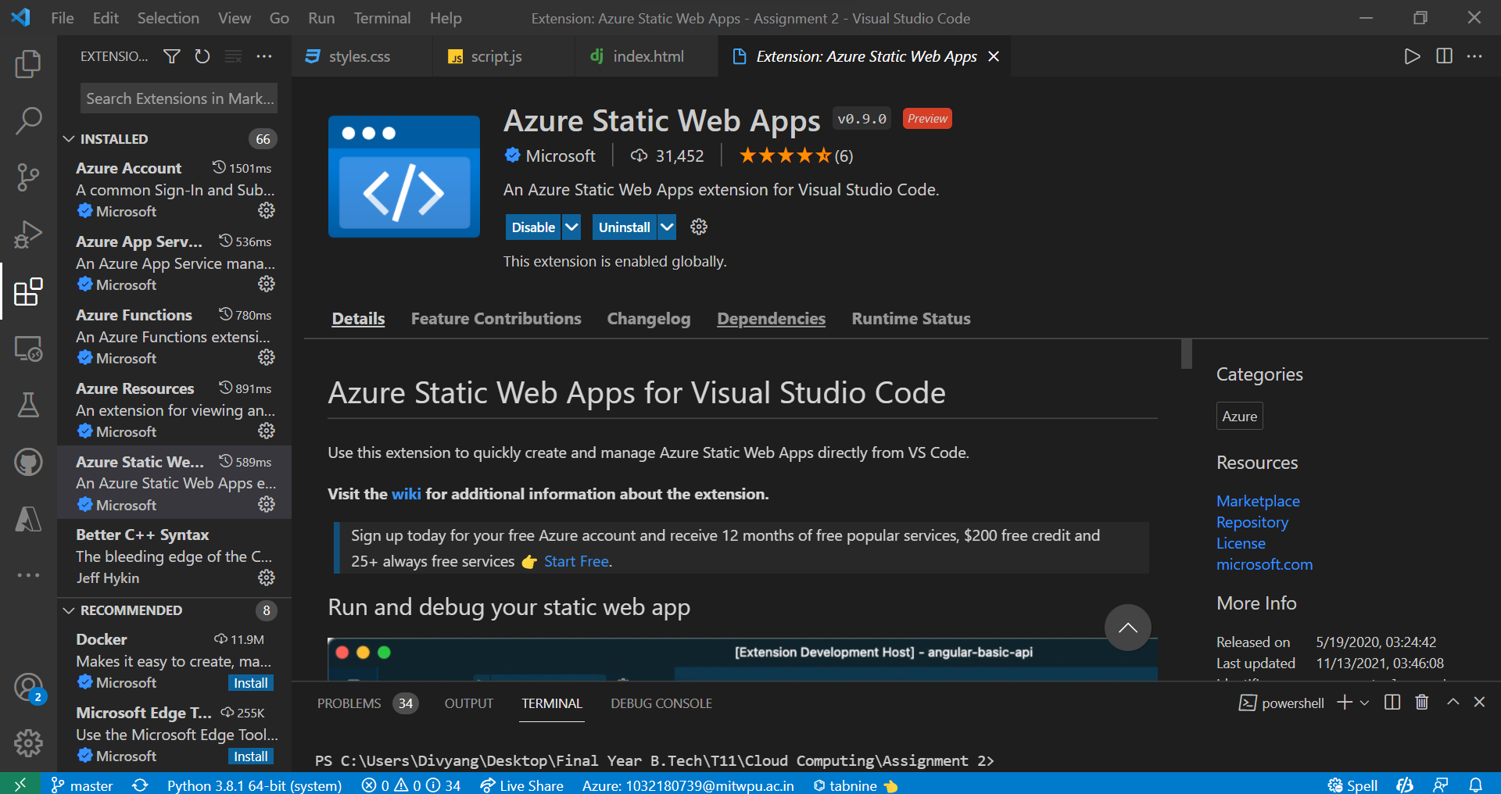

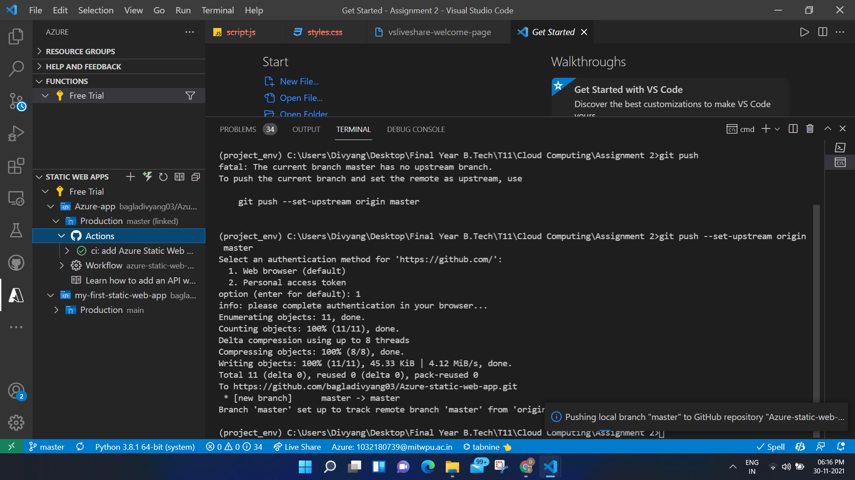

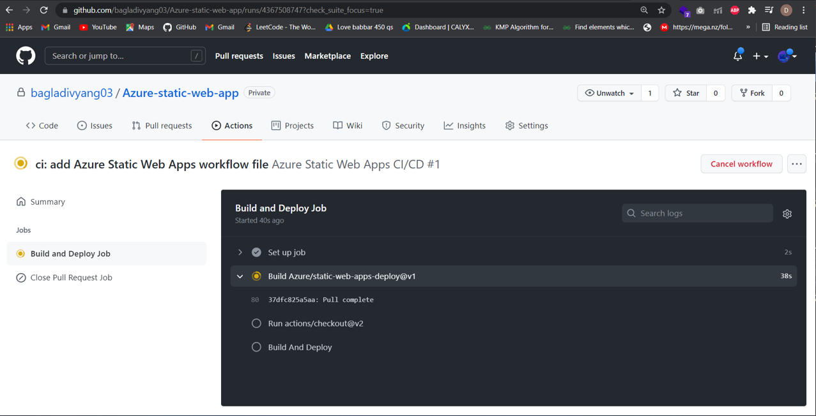

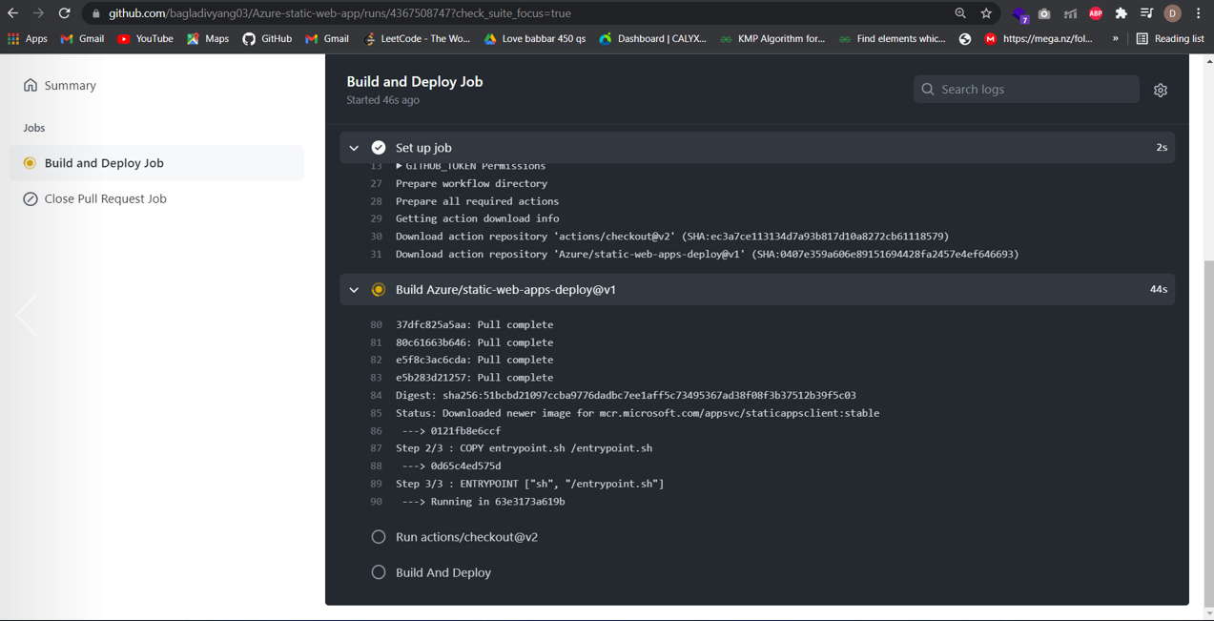

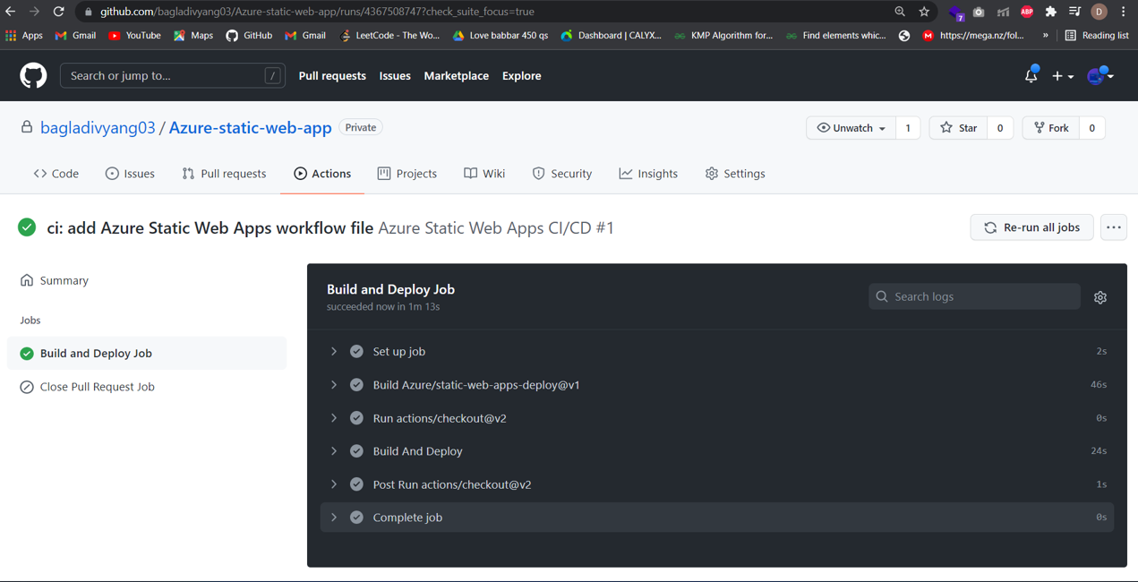

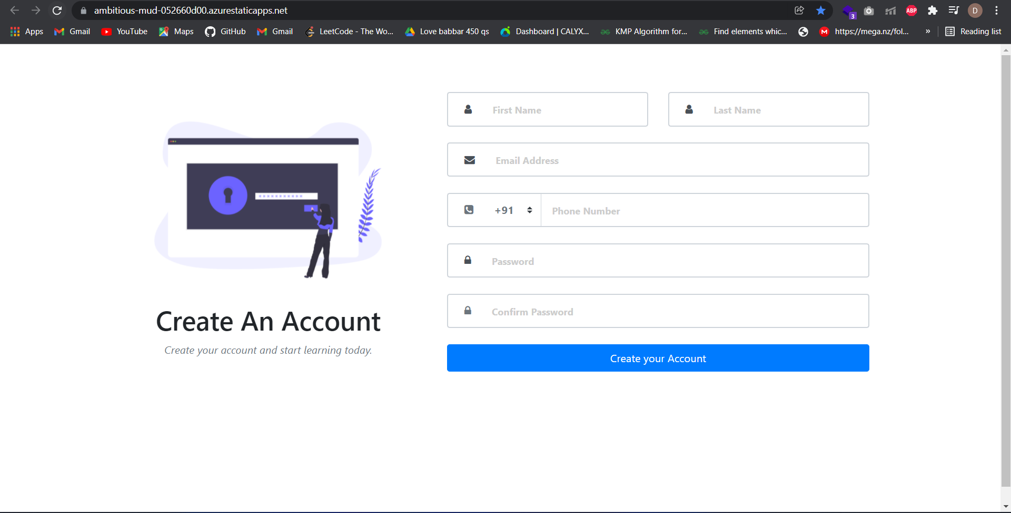

**Link of the deployed app:** <https://ambitious-mud-052660d00.azurestaticapps.net/>